Name:Husam Nour
PRN:25070122086

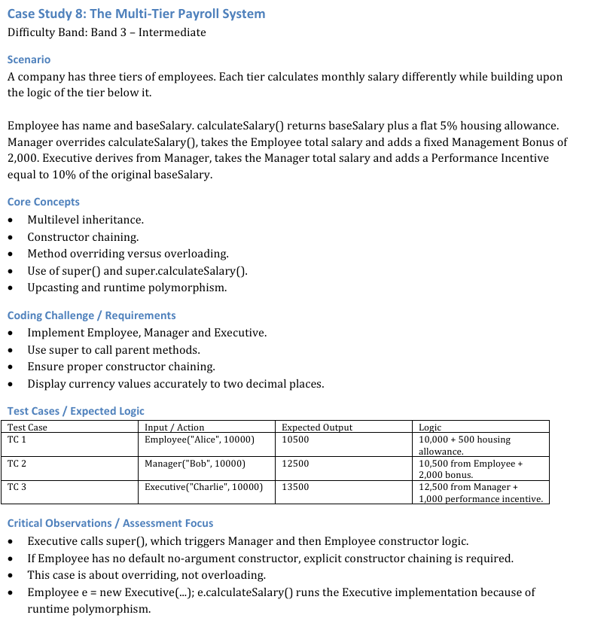
CODE FOR THIS PROGRAM
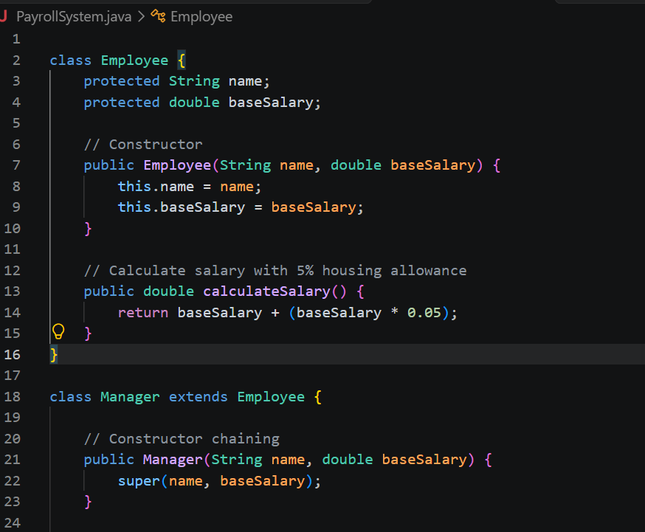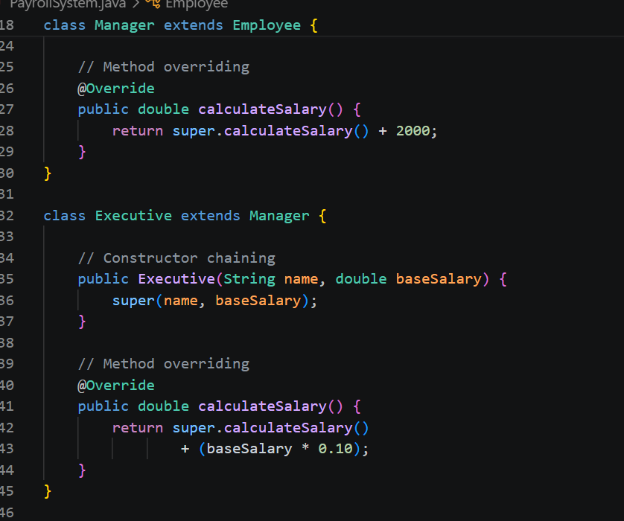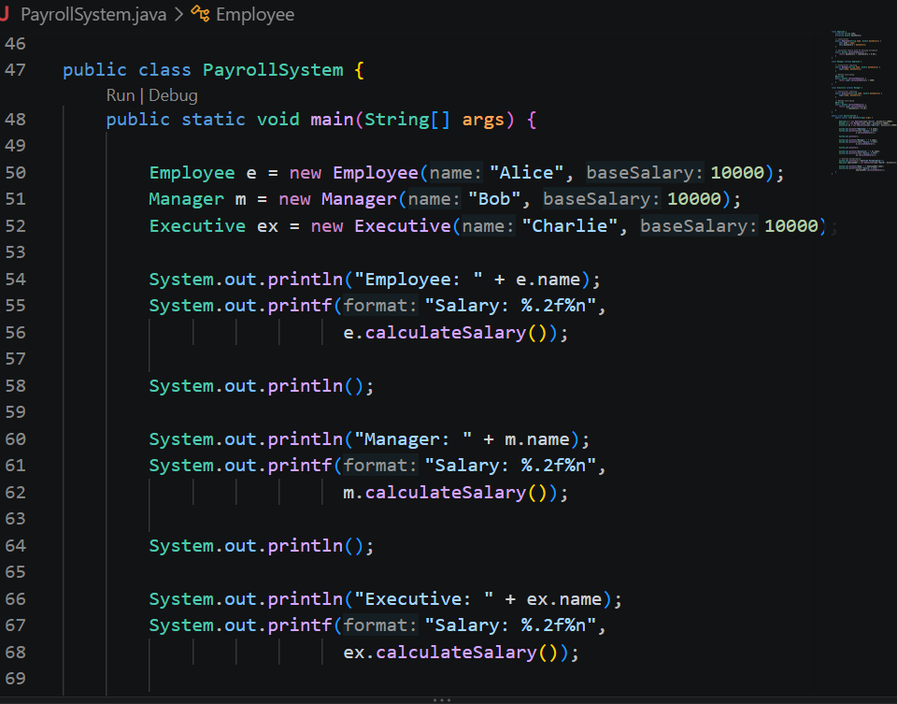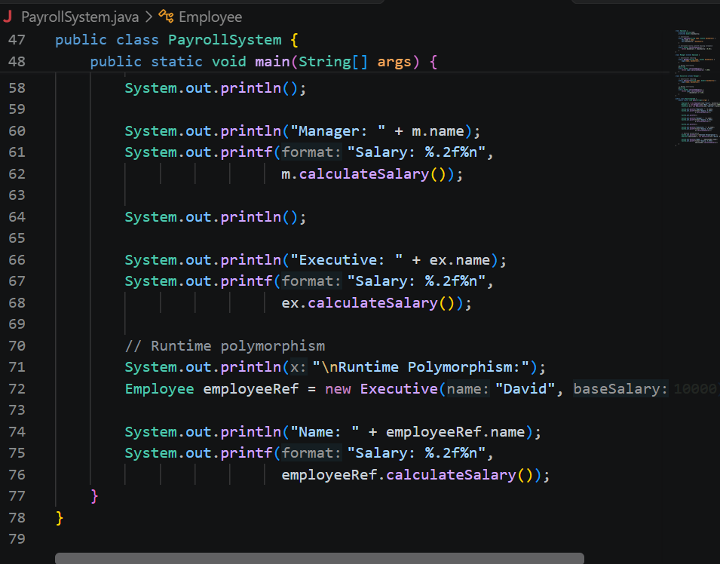
OUTPUT
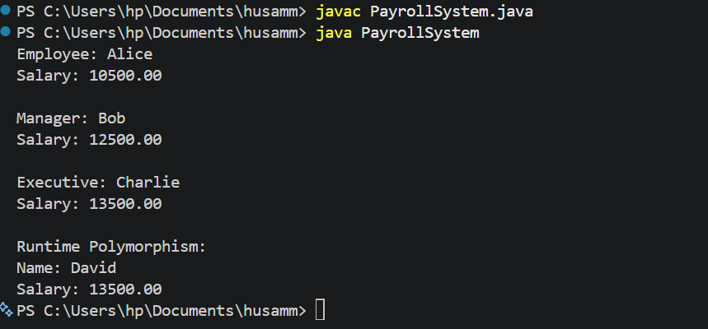
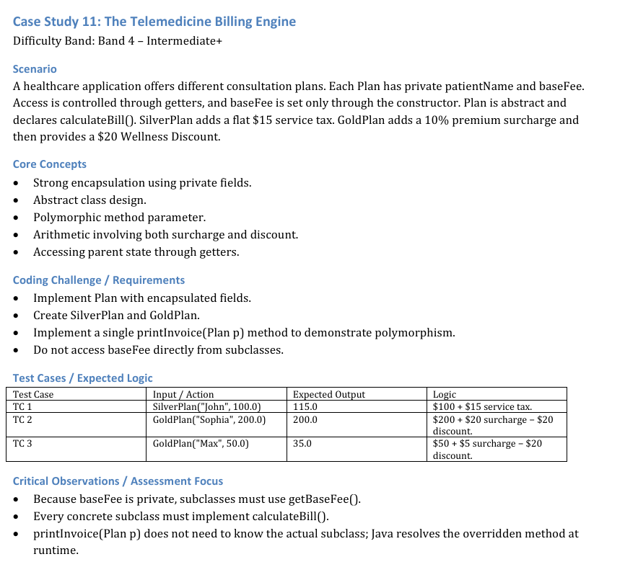

CODE
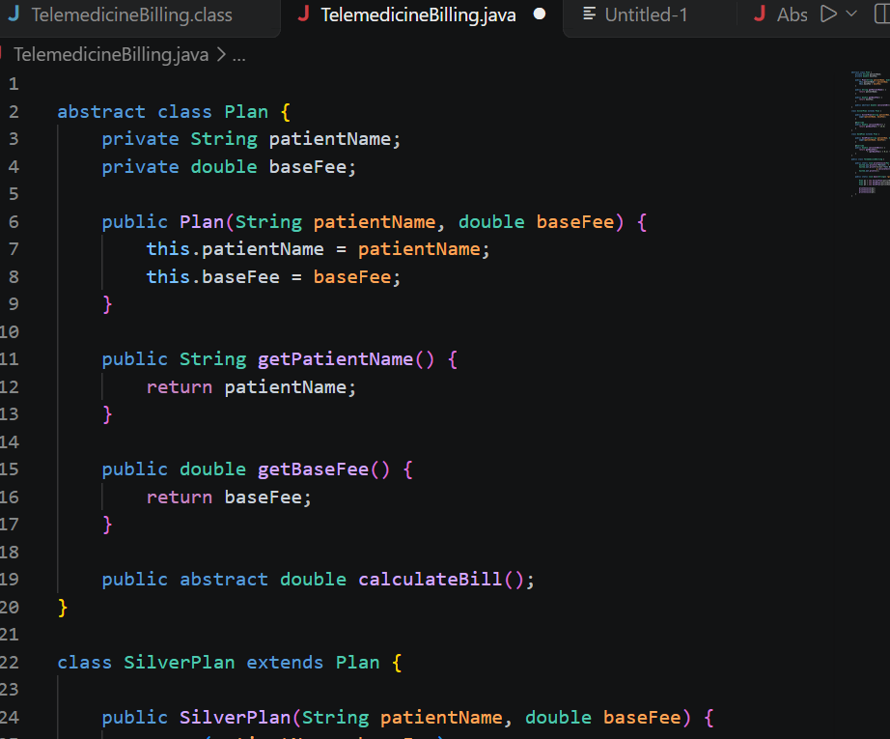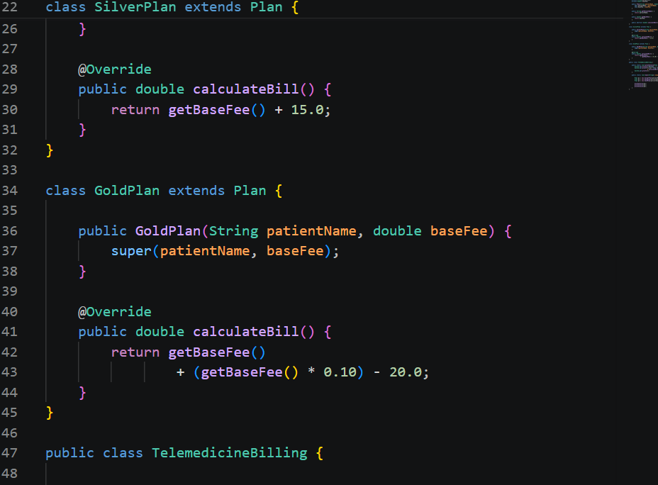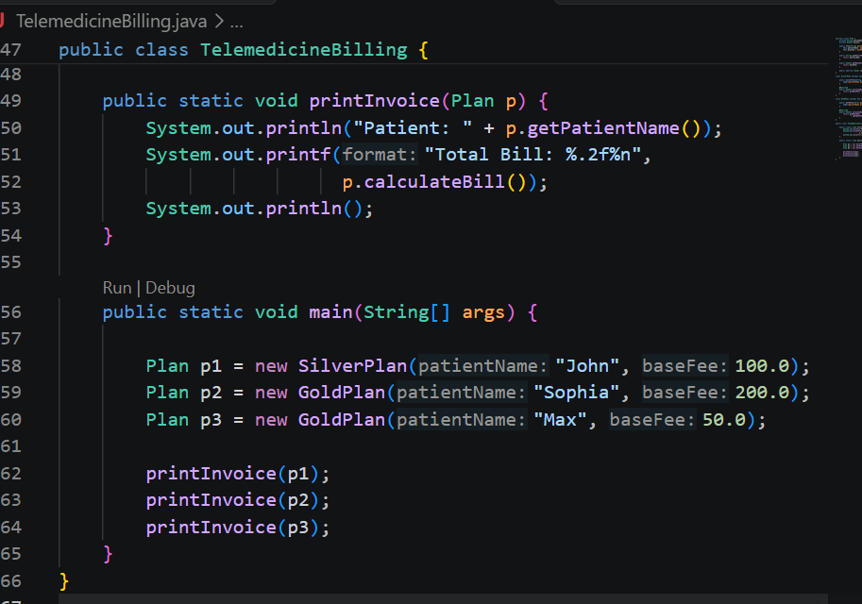
OUTPUT
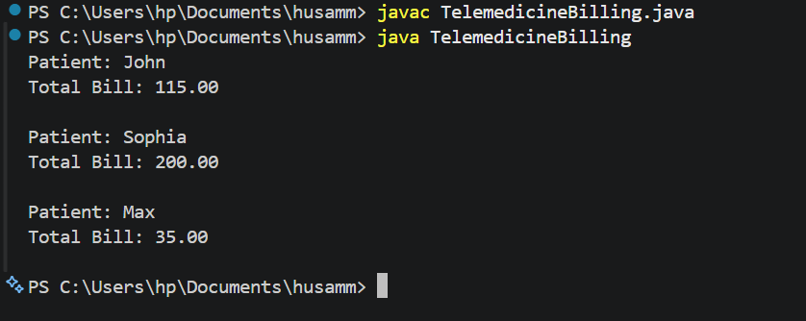

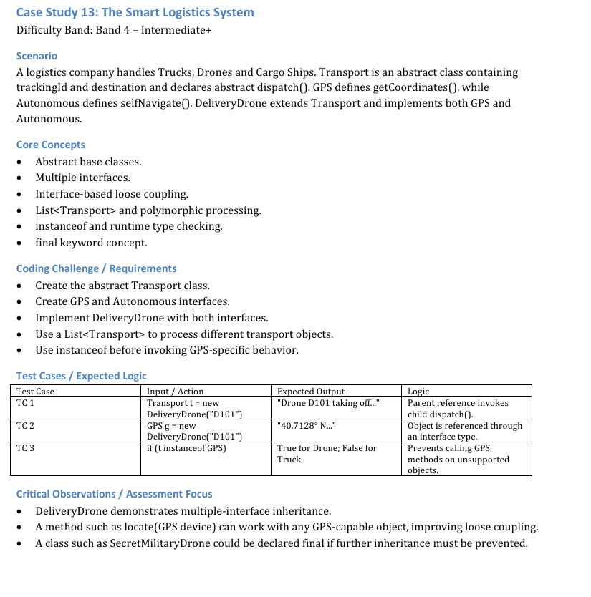
CODE

import java.util.ArrayList;
import java.util.List;

abstract class Transport {
protected String trackingId;
protected String destination;

public Transport(String trackingId, String destination) {
this.trackingId = trackingId;
this.destination = destination;
}

public abstract void dispatch();
}

interface GPS {
String getCoordinates();
}

interface Autonomous {
void selfNavigate();
}

class DeliveryDrone extends Transport
implements GPS, Autonomous {

public DeliveryDrone(String trackingId, String destination) {
super(trackingId, destination);
}

@Override
public void dispatch() {
System.out.println("Drone " + trackingId + " taking off...");
}

@Override
public String getCoordinates() {
return "40.7128° N, 74.0060° W";
}

@Override
public void selfNavigate() {
System.out.println("Drone " + trackingId
+ " navigating autonomously.");
}
}

class Truck extends Transport {

public Truck(String trackingId, String destination) {
super(trackingId, destination);
}

@Override
public void dispatch() {
System.out.println("Truck " + trackingId
+ " starting delivery...");
}
}

class CargoShip extends Transport {

public CargoShip(String trackingId, String destination) {
super(trackingId, destination);
}

@Override
public void dispatch() {
System.out.println("Cargo Ship " + trackingId
+ " sailing to " + destination + "...");
}
}

public class SmartLogistics {
public static void main(String[] args) {

// Test Case 1: Polymorphism
Transport t = new DeliveryDrone("D101", "New York");
t.dispatch();

System.out.println();

// Test Case 2: GPS interface
GPS g = new DeliveryDrone("D101", "New York");
System.out.println(g.getCoordinates());

System.out.println();

// Test Case 3: instanceof
Transport drone = new DeliveryDrone("D101", "New York");
Transport truck = new Truck("T101", "Pune");

System.out.println(drone instanceof GPS);
System.out.println(truck instanceof GPS);

System.out.println();

// Process different transport objects
List<Transport> transports = new ArrayList<>();
transports.add(new DeliveryDrone("D101", "New York"));
transports.add(new Truck("T101", "Pune"));
transports.add(new CargoShip("S101", "Mumbai"));

for (Transport item : transports) {
item.dispatch();

if (item instanceof GPS) {
GPS gpsDevice = (GPS) item;
System.out.println("Coordinates: "
+ gpsDevice.getCoordinates());
}

if (item instanceof Autonomous) {
Autonomous auto = (Autonomous) item;
auto.selfNavigate();
}

System.out.println();
}
}
}

OUTPUT
